3SK3 Project Part 1

Hanxi Huang

Huangh32 1303296

2017-02-18

1. technical problem and challenge

Because I want the user to select the sample image, there will be some decimal numbers. However, the sample image is only for integer, I have to round the decimal numbers up.

When I tried to compare sample image and matched image, the two figures could be very close, but not the same. If the difference is not small enough, such as 0.002, it may be have multiple match images. I think the most challenge part is understand the summed area table. I have to figure out each parts in the equations by using loops.

1. Algorithm

The original image is RGB image, the program transfer the RGB to Grey image in double type. Then I want to calculate A+B and A+C part. Take A+B part as example, I start from the first element in row 1. The loop is try to sum up all the rows just like the A+B shown in the pictures.

After that, I want to sum up the summed table.

Due to I want the user to pick the sample image, I use ”getrect” function to achieve my target. The sum function is based on the function the project description provided. Then I get the sample average by divided the image size.

The last part is matching image. The basic idea is to compare the mean values of the size of the image starting from (1,1) to (R – number of row of the image, C – number of column of the image. The difference between sample image and match image must be very small, otherwise, it could be multiple images matched.

1. strengths and weaknesses

I think the positive point for my program is the user can pick up whatever sample images they like and the logic for the computation process is very clearly.

The weaknesses is that for my program, the difference must be small enough. That’s because there are many decimal number for different sample images, when the program round it up, it could be some small errors.

1. Answer the questions

It’s depends on the size of the template. If you just use 32 bit IEEE format, the digits behind the decimal point you can represents will be less than 64 bits. Therefore, due to the reducing of the number, the similar number will be increasing compared to the sample average. Thus, more matched point will be shown on the screen.

1. 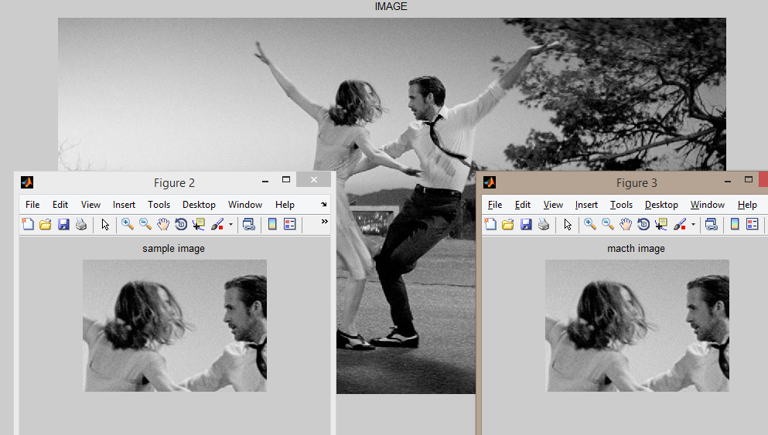Result